
Richard Bangs’ Adventures with Purpose
Assam India: Quest for the One-Horned Rhinoceros
Photos and Captions:

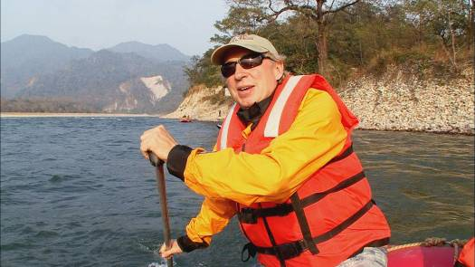
Modern explorer Richard Bangs runs the Brahmaputra River in northeastern India on his latest American Public Television special Adventures with Purpose—Assam India: Quest for the One-Horned Rhinoceros. In the far, far reaches of India, in the shadow of the Himalayas and along the misty banks of the Brahmaputra glides a grey blur that almost became a ghost—the one-horned rhinoceros—a rare species that a hundred-years-ago nearly vanished from the earth. What kept the rhino from falling into the chasm of extinction? What can its story teach us about our world today? Richard is on a quest to discover what saved the species, what the one-horned rhino means to the people of Assam, and why it flourishes in Assam as no where else. Adventures with Purpose—Assam India


Renowned adventurer and award-winning travel writer Richard Bangs visits a Vishnu Temple on Majuli Island in Assam India on his latest American Public Television special from Small World Productions and KCTS. Bangs is on a Quest for the One-Horned Rhinoceros, a rare species that a hundred-years-ago nearly vanished from the earth. He examines what kept the rhino from falling into the chasm of extinction. And what Assam’s success story in preserving the rhino can teach us about our world today and about saving other precious wildlife. Leader of 35 first descents of rivers around the globe, a mountain climber and renowned author, Richard brings a lifetime of experience to Adventures with Purpose—Assam India: Quest for the One-Horned Rhino.

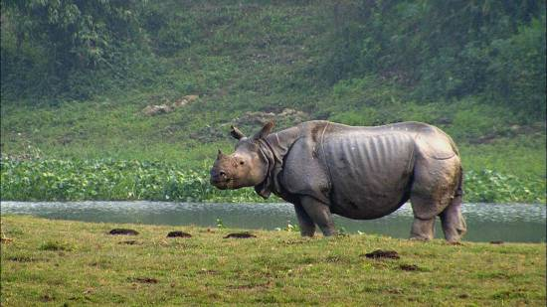
Adventures with Purpose—Assam India: Quest for the One-Horned Rhinoceros On the sixth installment of this series of specials from American Public Television, adventure travel author Richard Bangs is in Assam, a remote state on the northeastern corner of India. In the shadow of the Himalayas and along the misty banks of the Brahmaputra River glides a grey blur that almost became a ghost—the one-horned rhinoceros—a rare species that a hundred-years-ago nearly vanished from the earth. What kept the rhino from falling into the chasm of extinction? What can its story teach us about our world today? What does the one-horned rhino means to the people of Assam, and why does it flourish in Assam as no where else? The series is produced by Small World Productions of Seattle and co-produced by KCTS/Seattle. KCTS is the presenting station to APT. Adventures with Purpose—Assam India: Quest for the One-Horned Rhino airs on hundreds of public television stations across the country.

Corporate underwriting is provided in part by: Exofficio Travel Apparel—www.Exofficio.com & AdventureLink.com

Small World Productions
140 Lakeside Avenue, Suite 200
Seattle, WA, USA 98122

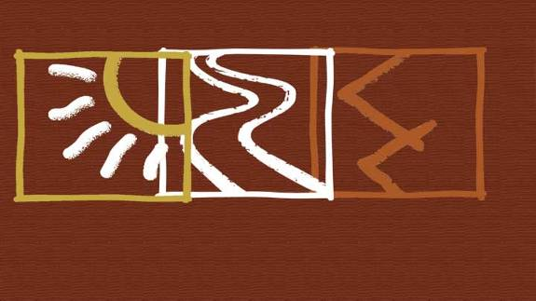
Morocco: Quest for the Kasbah
Assam India: Quest for the One-Horned Rhino
